**PROJECT REPORT ON**

Advanced Password Cracker with GUI in Python

Submitted by

**Mourya Birru: ST#IS#7414**

Under the Supervision of

**UPENDRA  
Senior Security Analyst**

**KRISHNA  
Security Analyst**



**Registered and Head Office**

**D.NO: 11-9-18, 1st Floor**

**Majjavari Street, Kothapeta,**

**Vijayawada – 520001.**

**+91 9550055338 / +91 7901336873**

**contact@suprajatechnologies.com**

**COMPANY INTRODUCTION:**

Supraja Technologies is a leading Knowledge and Technical Solutions Provider and pioneer leader in IT industry, is operating based out of Vijayawada.

**R&D at Supraja**

With a 24X7 work in Research & Development, experts at Supraja Technologies work under our :

• **Supraja Technologies Cyber Security Cell**

**About Supraja Technologies:**

**Supraja Technologies (a unit of CHSMRLSS Technologies Pvt. Ltd.**) with its foundation pillars as Innovation, Information and Intelligence is exploring indefinitely as a **Technology Service Provider (Corporate Consulting)** and as a **Training Organization (Ed-Tech)** as well.

You may visit us at :

[www.suprajatechnologies.com](http://www.suprajatechnologies.com)

The multi domains of trainings which Supraja Technologies operate include the following :

• **Workshops & Hackathons**

o Engineering Colleges

o Corporate Companies (Startups & MNC’s)

o Government Organizations

• **Classroom Trainings Cum Certification Courses**

o Summer Training (30-45 Days)

o Winter Training (10 - 15 Days)

o Weekend Training (2 Days)

o 1 Month / 3 Months / 6 Months Courses

• **On-site Trainings**

o Value Added Courses / Two Credit Courses for Colleges

o Faculty Development Programs

o College Summer Training (15 Days, 30 Days, 45 Days & 60 Days)

o Govt Agencies, Police Academies, Corporates etc

• **Cloud Campus**

o (Distance Learning Program) *Coming Soon

• **Internships**

o Internship for Engineering Students (30 Days, 45 Days & 60 Days)   
o Internship for Graduates (6 Months)

• **Lab Setup**

o Cyber Lab

• **CoE**

o Cyber Security Centre of Excellence

• **Supraja Technologies Security Assessment Product**

o (Our SaS Product is currently under development) *Coming Soon

**Why Supraja Technologies:**

Be it Training or a workshop, the course content is always from R&D Cell of Supraja.

* A proven track record of delivering quality services.
* **68,500+** Students trained by our trainers till date.
* Training Partners of recognized institutions.
* Trainers with excellent research and teaching pedagogy illustrate their findings through corporate standard **practical demonstrations** during their sessions.
* Easy to learn and **hands-on sessions** are given, with additional benefits of Study Material, Tool kit and immediate query handling.
* Self-Prepared **Cyber Security Cell.**
* Supraja Technologies has the best, experienced and highly **skilled bunch of R&D Engineers, Security Analysts, Security Consultants & Trainers.**
* We provide training in Innovating and Trending Technologies to Govt. Officials, Corporate Houses and Colleges.
* **Something we are proud of :**

1. Supraja Technologies CEO Mr.Santosh Chaluvadi is an Alumni of Potti Sriramulu Chalavadi Mallikharjuna Rao College of Engineering and Technology, Vijayawada.

With our CEO this college conducted/organised a 50 hours Nonstop Marathon Training Workshop on Ethical Hacking & Cyber Security for which this respective college and our CEO both holds their name in **“LIMCA BOOK OF RECORDS 2017”**

1. We are very happy to inform you all that our company, Supraja Technologies has been shortlisted for **"Top 50 Tech Companies" award 2019**, conferred at InterCon - Dubai, UAE.

Supraja Technologies is one out of thousands companies that were initially screened by InterCon team of 45+ research analysts over a period of three months and the final shortlist includes 150+ firms and we are very proud to inform you all that our company Supraja Technologies also happens to be a part of the same.

* **Life changing solution/service :**

After working on R&D for around 2 years, finally in the mid 2019 we have successfully developed a service/solution of various techniques and strategies for the Film Industry through which he can kill piracy of any film in online up to 35% right now. This betaservice is being appreciated & adopted by various Tollywood Film Industry Producers & Hero’s to safeguard their film from piracy in online and to gain more profits.

By the end of 2033 our vision is to rollout a complete full packed service/solution where we can kill piracy entirely 100% everywhere in online for sure.

## Appreciation : Received a great appreciation from our 1st Tollywood Film Industry client Mr.Saptagiri for providing our Anti-Piracy betaservice for his film VAJRA KAVACHADARA GOVINDA

* **Achievements:**
* On 17th August 2024, We (Supraja Technologies) launched our company’s

**Centre of Excellence in Cyber Security** (CoE) at Ramco Institute of Technology, Rajapalayam

* On 18th September 2024, We (Supraja Technologies) launched our company’s

**Centre of Excellence in Cyber Security** (CoE) at SRM University (Ramapuram Campus), Chennai

* On 20th November 2024, We (Supraja Technologies) launched our company’s

**Centre of Excellence in Cyber Security** (CoE) at St.Joseph’s Institute of Technology, Chennai

**Our Company Supraja Technologies   
is one of the emerging startup   
in Andhra Pradesh   
with 4.8 Google Ratings**

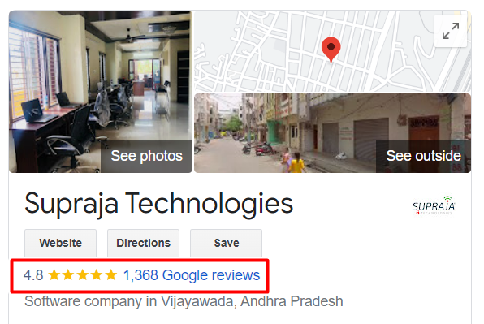

**Link :** [**https://bit.ly/SuprajaGoogle**](https://bit.ly/SuprajaGoogle)

**AND  
  
also check our Company CEO Instagram Profile   
for our recent more success stories:**<https://www.instagram.com/chaluvadisantosh/>



**Santosh Chaluvadi**

**Founder & CEO   
Supraja Technologies**

He is a 28-year-old entrepreneur, one of the India’s efficient Cyber Security Analyst and also he is an expert Digital Marketer as well. He is a digital marketer by profession and security enthusiast by passion. He primarily focuses on content building, testing and monetization of blogs. He has successfully developed many websites and done the security testing himself to ensure that the user’s data is in safe hands and their privacy is protected. He is very active on social media and shares lot of tech stuff with his followers. The young student hacker has solved many issues with the vulnerabilities present in various websites and databases, given a solution in clearing the loopholes in order to protect the data to be leaked from the databases. Besides Ethical Hacking & Cyber Security, he also has a passion in Blogging & Digital Marketing.   
  
  
While pursuing his engineering itself, he has trained many young generation people/students of more than 3500+ from various parts across Andhra Pradesh through his workshops, seminars, courses in Cyber Security and this makes him one of the youngest student trainers in India.

At the age of 20 he conducted his first workshop on Blogging & Ethical Hacking which was the beginning to his success in this field and right now he has handful of workshops to train students, government and corporate organizations as well in Andhra Pradesh & Telangana. He is the only student trainer who started conducting workshop for his peers, professors and for corporates.

The year 2016 gave me the conviction and confidence to notch up whatever I was doing. I’d organized a 50-hour marathon event on Ethical Hacking and Cyber Security in PSCMR College, Vijayawada that went on to bag to achieve Limca Book of Records for non-stop longest duration workshop. The impact we were making was clearly visible by now. Diverse people from Jammu & Kashmir in the North to Kanyakumari in the South had attended the event. Some of the Government of India officials took notice of this record and invited our team for couple of conferences at New Delhi. The country’s esteemed institutions were reaching out to me to conduct training, workshops, and events on a myriad of subjects related to online security. Multi-National Corporations (MNC’s) had begun to consult me on the Cyber Security of their systems.

* **Life changing solution/service :**

After working on R&D for around 2 years, finally in the mid 2019 we have successfully developed a service/solution of various techniques and strategies for the Film Industry through which he can kill piracy of any film in online up to 35% right now. This betaservice is being appreciated & adopted by various Tollywood Film Industry Producers & Hero’s to safeguard their film from piracy in online and to gain more profits.

By the end of 2033 our vision is to rollout a complete full packed service/solution where we can kill piracy entirely 100% everywhere in online for sure.

**Appreciation:**Received a great appreciation from our 1st Tollywood Film Industry client Mr.Saptagiri for providing our Anti-Piracy betaservice for his film VAJRA KAVACHADARA GOVINDA

* **Our Company Achievements:**
* On 17th August 2024, We (Supraja Technologies) launched our company’s

**Centre of Excellence in Cyber Security** (CoE) at Ramco Institute of Technology, Rajapalayam

* On 18th September 2024, We (Supraja Technologies) launched our company’s

**Centre of Excellence in Cyber Security** (CoE) at SRM University (Ramapuram Campus), Chennai

* On 20th November 2024, We (Supraja Technologies) launched our company’s

**Centre of Excellence in Cyber Security** (CoE) at St.Joseph’s Institute of Technology, Chennai

* **Records, Appreciations, Awards & Recognitions etc at a glance :**

1. Holds a National Record in “Limca Book of Records – 2017”
2. Ex-Associate Member for National Cyber Safety and Security Standards (NCSSS)
3. Steering Committee Member for United Conference on Cyber Space (UNITEDCON 2020)
4. Judge for the Grand Finale of SIH (Smart India Hackathon 2024) Software Edition for the Nodal Centre at Sri Sai Ram Engineering College, Chennai which is an initiative by Ministry of Education (Govt. of India) and AICTE
5. Received Appreciation from Mr.Amit Narayan, Executive Director at Rajahmundry Asset   
   of Oil and Natural Gas Corporation Limited (ONGC) on 16th December, 2022 for training their employees on Cyber Security
6. Awarded as a "Karmaveer Chakra - 2019", on 12th October 2019 at IIT Delhi, which was instituted by iCONGO in partnership with the United Nations
7. Received Appreciation from Mr.Sandeep Rathore, Commissioner of Police, Chennai   
   on 2nd March 2024 for the exceptional commitment and invaluable contribution   
   as a Member of JURY at Greater Chennai Police Cyber Hackathon 3.0
8. Evaluator for the “Innovative Bharat” which is organized by AICTE and Ministry of Education held on 6th January 2024
9. Judge for the Grand Finale of SIH (Smart India Hackathon 2023) Senior Software Edition for the Nodal Centre at PVPSIT, Vijayawada which is an initiative by Ministry of Education (Govt. of India) and AICTE
10. Appointed as a Member for Board of Studies on 19th April 2025 for the Departments of Cyber Security, Data Science and AIML at Bapatla Engineering College, Bapatla
11. Appointed as a Member for Board of Studies on 12th March 2025 for the Department of Cyber Security at St. Joseph’s Institute of Technology, Chennai
12. Appointed as one of the Industry Academia Advisory Council Member on   
    30th September 2023 for the Department of Cyber Security at VNR Vignana Jyothi Institute of Engineering & Technology, Hyderabad
13. Appointed as a Member for Board of Studies on 4th May 2023 for the Department of Cyber Security at Madanapalle Institute of Technology & Sciences, Madanapalle
14. Appointed as a Member for Board of Studies for the Department of MCA at NRI Institute of Technology, Perecherla (Guntur)
15. Awarded as a “Social Media Influencer - 2019”, on 30th June 2019 by Jignasa   
    in association with Government of Andhra Pradesh
16. Nominated for “INDIA 500 CEO AWARD 2019”
17. Invited & Interviewed by ETV Andhra Pradesh news channel on 27th July, 2019 for a Special Story Interview on “Spy Apps”
18. Appreciated by Mr.Sridhar, Sub-Inspector of Police at Central Crime Branch, Vijayawada on 23rd October, 2018 for exclusively training him on Special Investigation Course, which will help him to solve the cyber crime cases easily
19. Received a great appreciation from our 1st Tollywood Film Industry client Mr.Saptagiri, for providing Anti-Piracy betaservice for his movie VAJRA KAVACHADARA GOVINDA

* **Something we are proud of :**

We are very happy to inform you all that our company, Supraja Technologies has been shortlisted for **"Top 50 Tech Companies" award 2019**, conferred at InterCon - Dubai, UAE.

Supraja Technologies is one out of thousands of startup companies that were initially screened by InterCon team of 45+ research analysts over a period of three months and the final shortlist includes 150+ firms and we are very proud to inform you all that our company Supraja Technologies also happens to be a part of the same.

**Some Glimpses of our Journey**

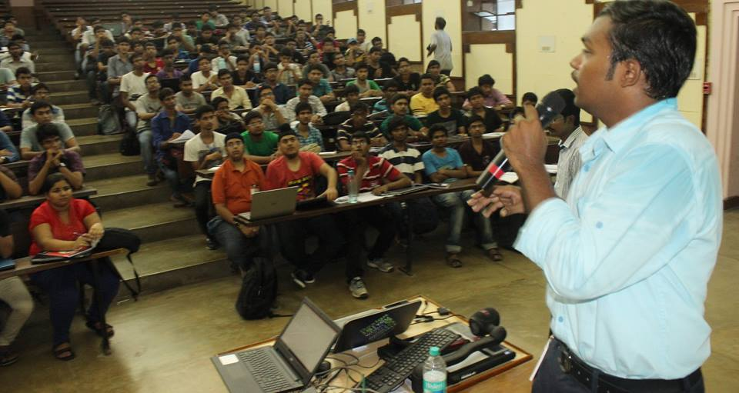

Mr.Santosh Chaluvadi – CEO, Supraja Technologies   
Giving hands-on Cyber Security training workshop to the CSE students   
at IIT Kharagpur

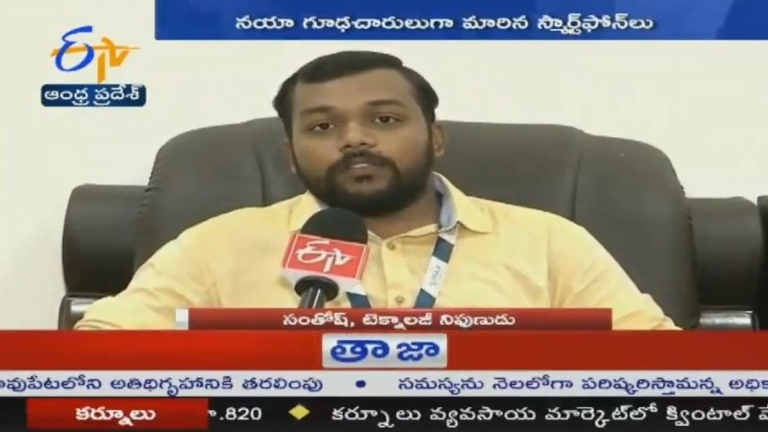

Mr.Santosh Chaluvadi – CEO, Supraja Technologies was

Invited & Interviewed by ETV Andhra Pradesh news channel on 27th July, 2019   
for a Special Story Interview on “Spy Apps”

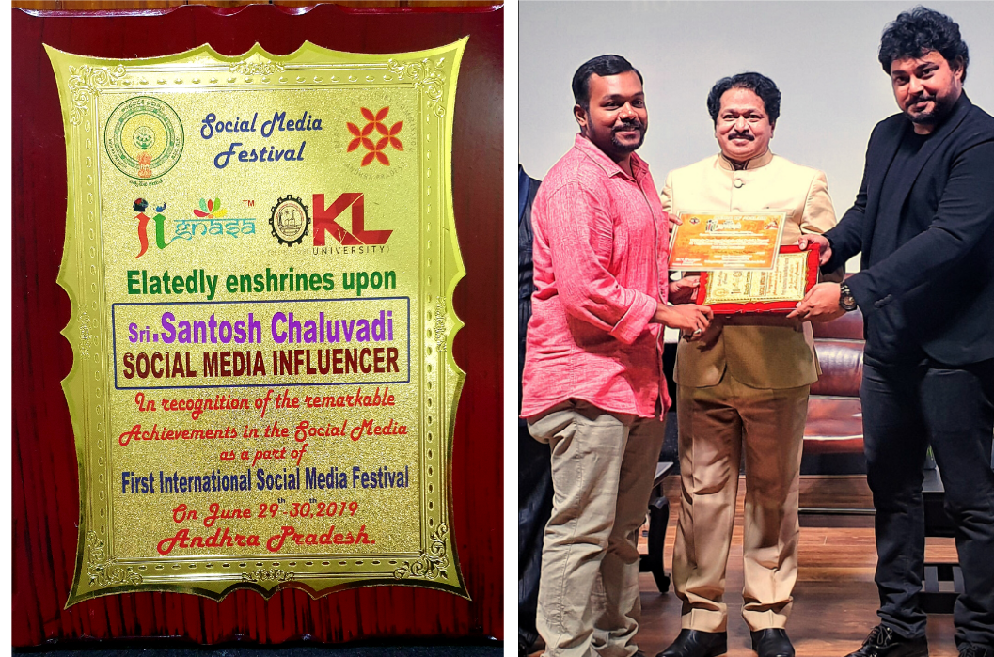

Mr.Santosh Chaluvadi – CEO, Supraja Technologies was awarded as a   
**"Social Media Influencer 2019"** in recognition of his remarkable achievements in the social media as a part of First International Social Media Festival on 30th June 2019 by Jignasa in association with Government of Andhra Pradesh

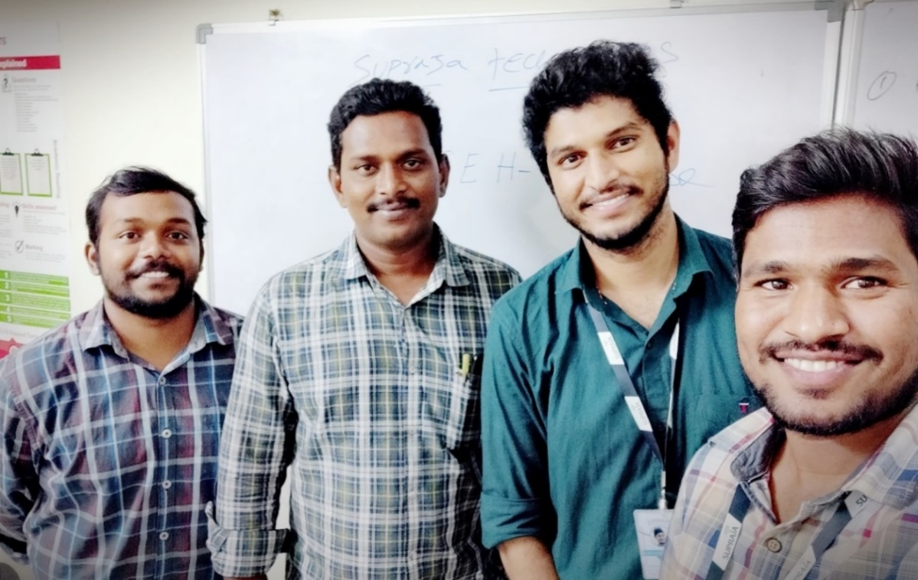

On 23rd October 2018 Mr.Santosh Chaluvadi, CEO - Supraja Technologies and Mr.Krishna Chaitanya, CTO - Supraja Technologies had successfully completed delivering Special Investigation Course training in Cyber Security to Mr.Sridhar Garu, Sub-Inspector of Police at Central Crime Branch, Vijayawada which will help him to solve the cyber crime cases easily



ETV Andhra Pradesh News Channel interviewed Mr.Santosh Chaluvadi, CEO - Supraja Technologies for his achievements in the domain of Cyber Security & Digital Marketing

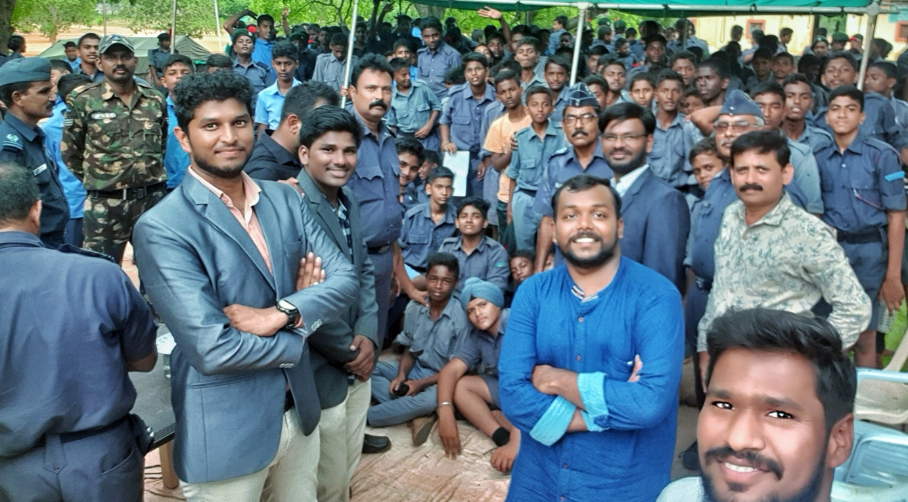

Supraja Technologies was invited by Indian Air Force (Air Wing NCC) to deliver a session on Latest Cyber Crimes & Awareness for the NCC cadets, staff and officers   
on 4th July, 2019

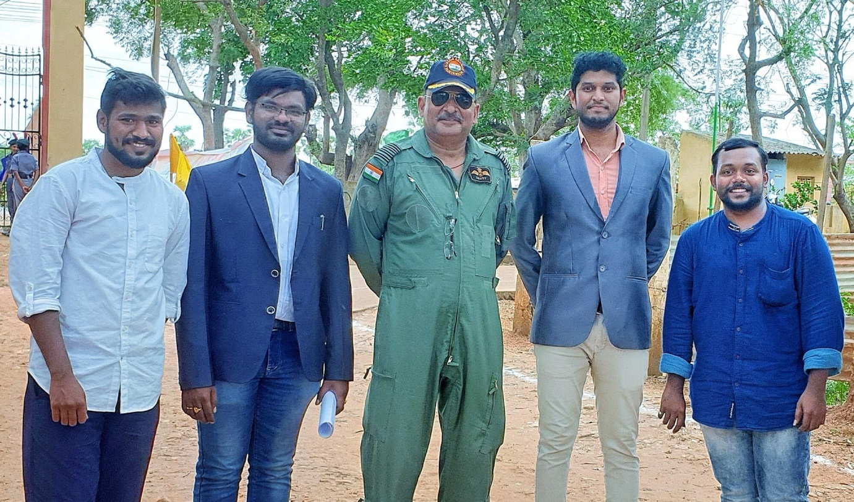

Supraja Technologies – CEO, CTO & CMO with   
Indian Air Force (Air Wing NCC) Group Captain Sandeep Gupta.  
We thank Mr.Sandeep Gupta for inviting us on 4th July, 2019 to deliver a session on Latest Cyber Crimes & Awareness for the Indian Air Force (Air Wing NCC) cadets, staff & officers

**Table of Contents**

1. Introduction
   1. Overall Description
2. Existing System
3. Proposed System
4. System Design
   1. Feasibility Study
   2. Input and Output Design
5. Implementation
   1. Module Description
   2. System Architecture
6. Algorithm Implementation
   1. Hash Cracking Algorithms
7. System Design
   1. Data Flow Diagram
   2. Use-Case Diagram
   3. Class Diagram
   4. Sequence Diagram
   5. Activity Diagram
   6. Component Diagram
   7. ER-Diagram
8. Requirement Specification
   1. Functional Requirements
   2. Software Requirements
   3. Operating Systems Supported
   4. Technologies and Languages Used
   5. Hardware Requirements
9. System Test
   1. Types of Test
   2. Test Strategy and Approach
   3. Integration Testing
   4. Acceptance Testing
10. Conclusion

**Introduction**

**Overall Description**

The Advanced Password Cracker is a comprehensive cybersecurity tool designed for ethical hacking, penetration testing, and security assessment purposes. This application provides a unified platform for various password cracking methodologies, including hash cracking, web form brute forcing, Wi-Fi password recovery, and NTLM hash cracking.

**Project Scope and Objectives**

The primary objective of this project is to develop a user-friendly, multi-functional password cracking tool that can assist cybersecurity professionals, ethical hackers, and security researchers in evaluating the strength of password-based authentication systems. The application aims to:

1. **Educational Purpose**: Demonstrate various password cracking techniques and their implementations
2. **Security Assessment**: Provide tools for testing password strength in organizational environments
3. **Penetration Testing**: Assist in authorized security testing scenarios
4. **Research Applications**: Support cybersecurity research and development activities

**Key Features and Capabilities**

The Advanced Password Cracker incorporates four primary modules:

**Hash Cracker Module**: Supports multiple hashing algorithms including MD5, SHA1, SHA256, SHA512, NTLM, and BCrypt. This module can perform both dictionary-based attacks using wordlists and brute-force attacks with customizable character sets and password lengths.

**Web Brute forcer Module**: Designed to test web application login forms by automatically submitting login attempts using dictionary attacks. It includes configurable request parameters, timeout settings, delay mechanisms, and success detection capabilities.

**Wi-Fi Cracker Module**: Simulates Wi-Fi password cracking scenarios by processing captured handshake files and attempting to recover WPA/WPA2 passwords using dictionary attacks. This module supports both PMKID and handshake-based attacks.

**NTLM Cracker Module**: Specifically designed for cracking Windows NTLM password hashes, supporting both dictionary attacks and brute-force methodologies with customizable character sets.

**Technical Architecture Overview**

The application is built using Python with a Tkinter-based graphical user interface, implementing a multi-threaded architecture to ensure responsive user interaction during intensive cracking operations. The system utilizes various Python libraries including:

* **Tkinter**: For the graphical user interface
* **Threading**: For concurrent processing and non-blocking operations
* **Hashlib**: For cryptographic hash function implementations
* **Requests**: For HTTP-based web brute forcing operations
* **PyShark**: For network packet analysis (Wi-Fi module)
* **Queue**: For inter-thread communication and result handling

**Existing System Analysis**

**Current Password Cracking Landscape**

The current cybersecurity landscape includes numerous password cracking tools, each with specific strengths and limitations:

**Popular Existing Tools:**

* **John the Ripper**: Command-line based, excellent performance but challenging interface
* **Hashcat**: World's fastest password recovery tool with GPU acceleration, requires technical expertise
* **Hydra**: Network login cracking specialist, lacks integrated hash cracking
* **Aircrack-ng**: Wi-Fi security standard, operates entirely through command-line
* **Medusa**: Parallel login brute-forcer, limited to network services

**Limitations of Existing Systems**

1. **Fragmentation**: Tools specialize in specific attack vectors, requiring multiple applications
2. **User Interface Complexity**: Most operate through command-line interfaces
3. **Integration Challenges**: Manual data manipulation required for combined results
4. **Limited Educational Features**: Lack progress visualization and learning guidance
5. **Platform Dependencies**: Specific OS or hardware requirements limit accessibility

**Market Gap Analysis**

The analysis reveals several gaps:

* No unified interface for multiple attack methodologies
* Limited educational-focused tools
* Lack of real-time progress tracking
* Insufficient result management and reporting
* Limited cross-platform compatibility options

**Proposed System**

**System Overview and Innovation**

The Advanced Password Cracker addresses existing limitations by integrating multiple attack methodologies into a single, user-friendly platform while maintaining professional-grade capabilities.

**Core Innovation Elements**

**Unified Multi-Modal Interface**: Combines hash cracking, web bruteforcing, WiFi password recovery, and NTLM cracking into a single application with consistent user interface, eliminating the need for multiple tools.

**Educational-First Design**: Emphasizes educational value through visual progress indicators, detailed logging, and comprehensive result display mechanisms, making advanced techniques accessible to students and training professionals.

**Intelligent Progress Management**: Implements sophisticated progress tracking with pause/resume capabilities, real-time statistics, and predictive completion estimates for efficient resource management.

**Comprehensive Result Management**: Advanced result handling includes automatic categorization, export capabilities in multiple formats, and integrated reporting mechanisms supporting professional security assessment workflows.

**Technical Architecture Advantages**

* **Multi-Threading Architecture**: Advanced threading ensures responsive UI during intensive operations while maximizing system resource utilization
* **Modular Design Pattern**: Independent modules with standardized interfaces enable easy extension and maintenance
* **Cross-Platform Compatibility**: Consistent functionality across Windows, Linux, and macOS platforms
* **Scalable Performance Model**: Configurable threading and resource allocation for different hardware configurations

**System Design**

**Feasibility Study**

**Technical Feasibility Analysis**

Python was selected as the primary development language due to extensive cryptographic libraries, cross-platform compatibility, and robust threading support. Key feasibility factors:

* **Cryptographic Library Availability**: Python's hashlib provides comprehensive hash algorithm support
* **Network and Protocol Support**: Requests library offers robust HTTP/HTTPS support
* **Threading and Concurrency**: Sufficient capabilities for responsive UI with intensive background processing
* **File System Management**: Standard Python capabilities support large dataset handling

**Economic Feasibility Analysis**

* **Development Costs**: Entirely open-source technologies eliminate licensing costs
* **Hardware Requirements**: Operates on standard desktop/laptop computers without specialized hardware
* **Maintenance Costs**: Well-established libraries reduce long-term maintenance requirements
* **Training Costs**: Intuitive interface reduces user training requirements

**Operational Feasibility Analysis**

* **User Skill Requirements**: Accommodates varying technical skill levels from students to experts
* **Integration Capabilities**: Supports standard formats for existing workflow integration
* **Scalability**: Modular architecture supports individual to enterprise use
* **Deployment Flexibility**: Cross-platform compatibility ensures deployment flexibility

**Input and Output Design**

**Input Design Specifications**

* **Hash File Processing**: Standard text format with validation and format detection
* **Wordlist Management**: Multiple encoding support with streaming processing for large files
* **Configuration Parameters**: Comprehensive validation for numeric, text, and file inputs
* **Web Form Parameters**: HTTP POST format support with dynamic parameter substitution
* **WiFi Capture Files**: CAP and PCAP format processing with packet analysis

**Output Design Architecture**

* **Real-Time Progress Display**: Comprehensive feedback through progress bars, status labels, and live results
* **Result Categorization**: Automatic categorization by attack type and success status
* **Comprehensive Logging**: All operations logged with timestamps and configurable verbosity
* **Export Capabilities**: Multiple formats (text, JSON, CSV) with filtering options
* **Statistical Analysis**: Success rates, processing speeds, and resource utilization metrics

**Implementation**

**Module Implementation**

**Hash Cracker Module**

Core functionality implements comprehensive hash comparison algorithms supporting MD5, SHA1, SHA256, SHA512, NTLM, and BCrypt. Key features:

* **Dictionary Attack**: Streaming wordlist processing with encoding detection and conversion
* **Brute Force Engine**: Uses itertools.product for combination generation with progress estimation
* **Hash Detection**: Automatic format detection based on length and character patterns
* **Performance Optimization**: Multi-threading with workload distribution across CPU cores

**Web Bruteforcer Module**

Implements robust HTTP request handling with support for various authentication methods:

* **HTTP Request Engine**: Comprehensive request handling with retry mechanisms and timeout management
* **Form Parameter Processing**: Dynamic substitution for flexible login form testing
* **Success Detection**: Multiple methods including status code and content analysis
* **Rate Limiting**: Intelligent delay mechanisms preventing server overload

**WiFi Cracker Module**

Integrates packet analysis for educational WiFi security concepts:

* **Packet Analysis**: PyShark integration for handshake extraction and validation
* **PMKID Processing**: Modern WiFi attack methodology support
* **Educational Safety**: Simulation-based approach for safe learning environment

**NTLM Cracker Module**

Implements Windows authentication hash processing:

* **NTLM Hash Generation**: Accurate MD4 implementation with UTF-16LE encoding
* **Enhanced Character Support**: Unicode and special symbol accommodation
* **Optimized Algorithms**: Performance-optimized brute force with intelligent pruning

**System Architecture**

**Layered Architecture Pattern**

* **Presentation Layer**: Tkinter-based GUI with specialized tabs for different attack methodologies
* **Business Logic Layer**: Core algorithms, threading management, and result processing
* **Data Access Layer**: File I/O, network communications, and result storage abstraction
* **Cross-Cutting Concerns**: Logging, error handling, and security features spanning all layers

**Threading Architecture**

* **Main UI Thread**: Dedicated to user interface responsiveness
* **Worker Thread Pool**: Configurable pool handling password cracking with intelligent distribution
* **Result Processing Thread**: Dedicated result collection and display management
* **Logging Thread**: System monitoring without performance impact on core operations

**Algorithm Implementation**

**Hash Cracking Algorithms**

**Dictionary Attack Algorithm**

Algorithm: Dictionary Attack

Input: target_hashes[], wordlist_file, hash_type

Output: cracked_passwords[]

1. Initialize result_set = empty

2. Load target_hashes from input file

3. Validate hash format and type

4. Open wordlist_file for streaming read

5. For each password in wordlist:

a. Generate hash using specified hash_type

b. Compare with each target_hash

c. If match found:

- Add to result_set

- Log successful crack

- Update progress display

d. Update progress counters

e. Check for pause/stop conditions

6. Return result_set

**Performance Optimizations**:

* Streaming processing for large wordlists minimizing memory consumption
* Hash caching for frequently tested passwords
* Early termination when all hashes cracked
* Multi-threading with intelligent workload distribution

**Brute Force Attack Algorithm**

Algorithm: Brute Force Attack

Input: target_hashes[], char_set, min_length, max_length, hash_type

Output: cracked_passwords[]

1. Initialize result_set = empty

2. Calculate total_combinations = sum(|char_set|^i for i in [min_length..max_length])

3. For length = min_length to max_length:

a. Generate all combinations of char_set with length

b. For each combination:

- Convert to password string

- Generate hash using hash_type

- Compare with target_hashes

- If match found, add to result_set

- Update progress (current/total_combinations)

- Check pause/stop conditions

4. Return result_set

**Hash-Specific Implementations**:

def generate_md5_hash(password):

return hashlib.md5(password.encode('utf-8')).hexdigest()

def generate_ntlm_hash(password):

return hashlib.new('md4', password.encode('utf-16le')).hexdigest()

**System Design Diagrams**

**Data Flow Diagram**

The Data Flow Diagram (DFD) for the Advanced Password Cracker illustrates the movement of data through the system, showing how information flows between different processes, data stores, and external entities.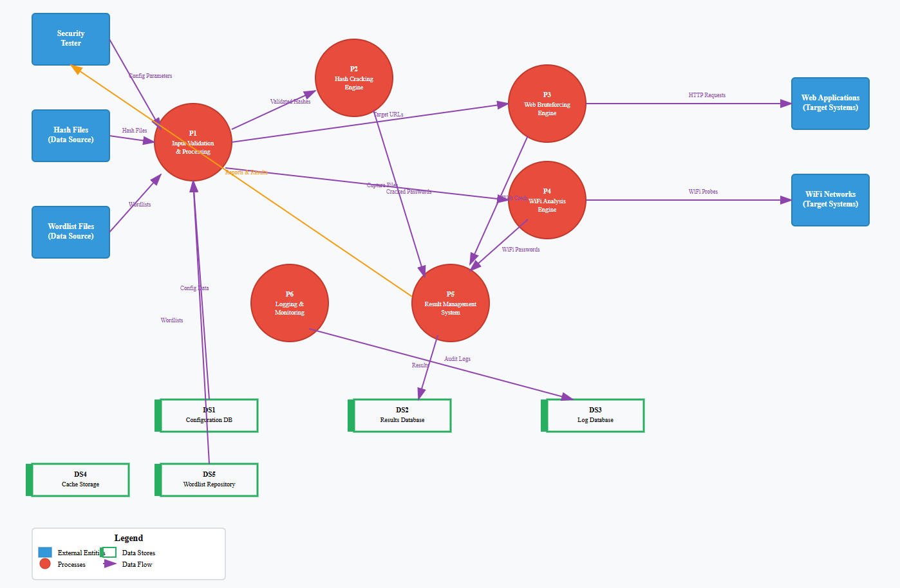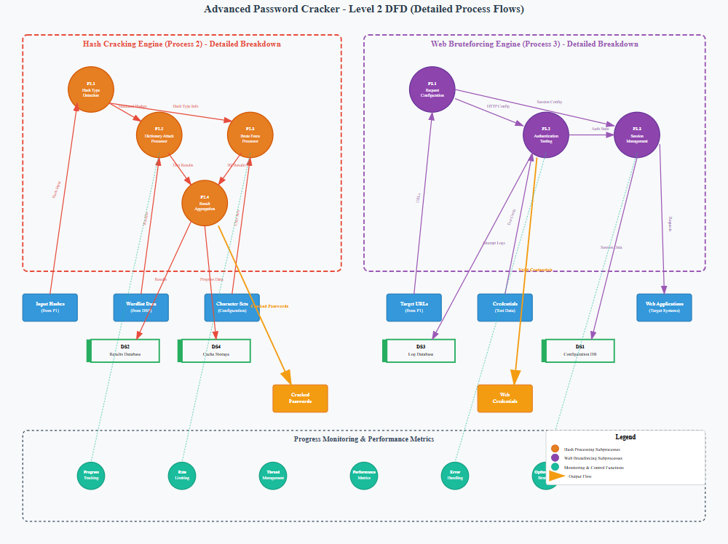

**Use-Case Diagram**

The Use-Case Diagram illustrates the functional requirements of the Advanced Password Cracker from the user's perspective, showing the interactions between different types of users and the system functionalities.

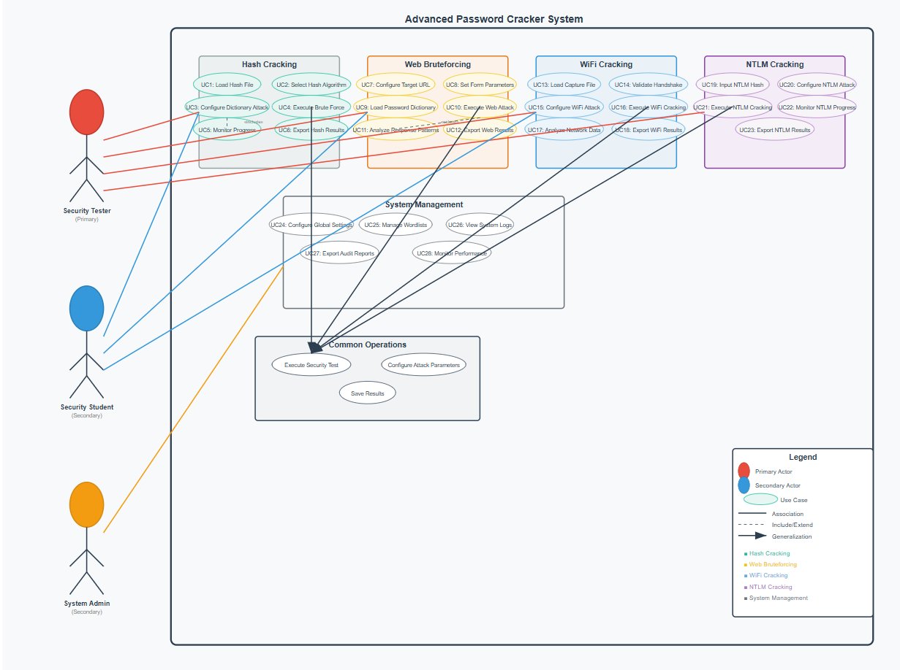

**Class Diagram**

The Class Diagram represents the static structure of the Advanced Password Cracker system, showing classes, their attributes, methods, and relationships.

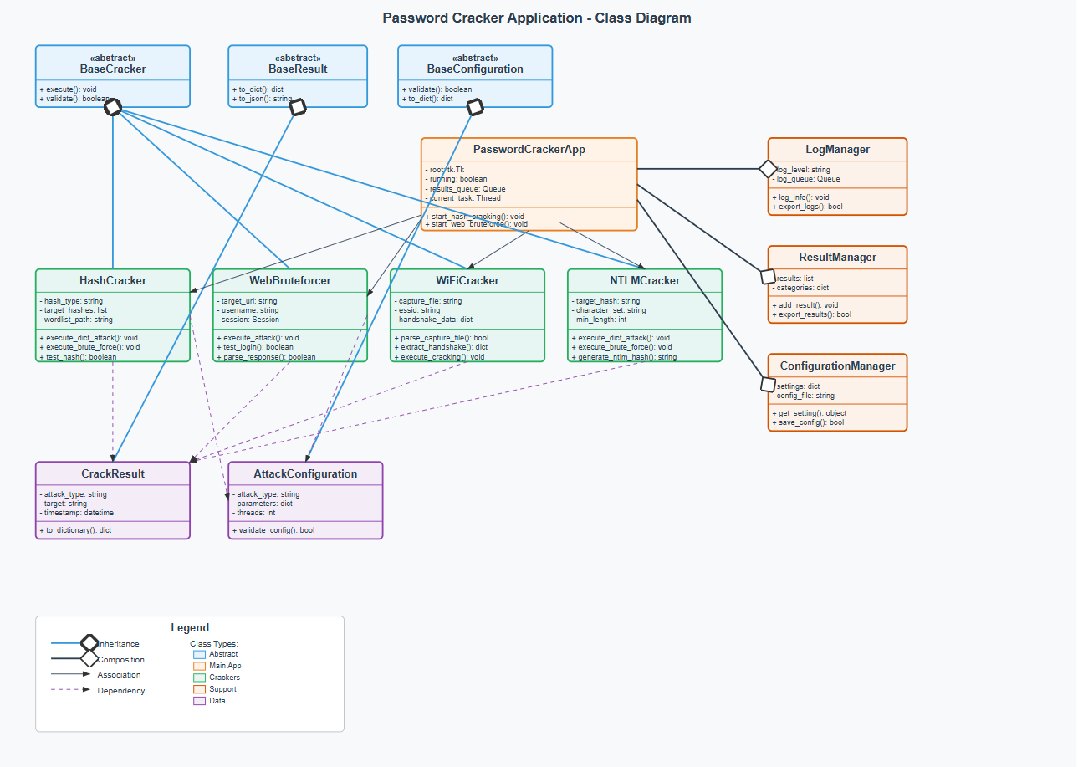

**Sequence Diagram**

The Sequence Diagram illustrates the dynamic behavior of the Advanced Password Cracker system, showing the interactions between objects over time for key use cases.

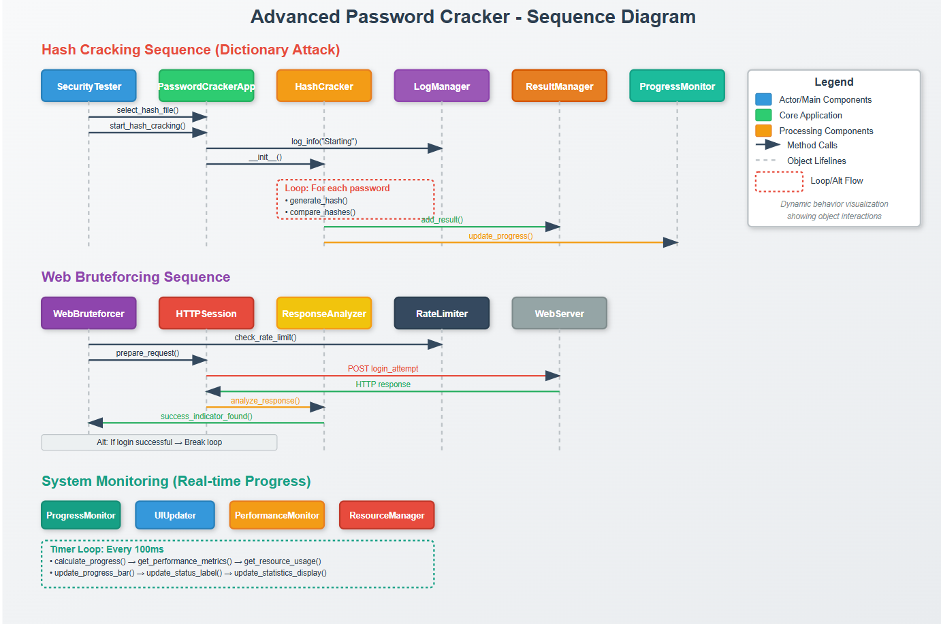

**Activity Diagram**

The Activity Diagram shows the workflow and decision points within the Advanced Password Cracker system, illustrating the flow of activities from start to completion for various attack scenarios.

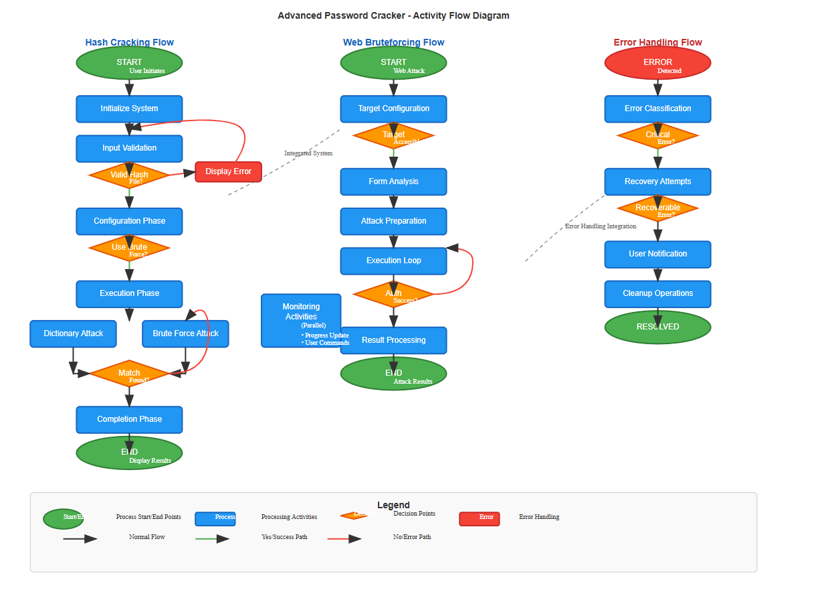

**Component Diagram**

The Component Diagram illustrates the high-level structure of the Advanced Password Cracker system, showing the organization of components and their interfaces and dependencies.

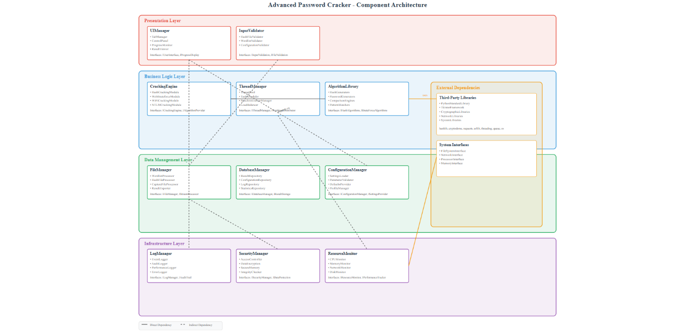

**ER-Diagram**

The Entity-Relationship Diagram represents the data model for the Advanced Password Cracker system, showing the relationships between different data entities and their attributes.

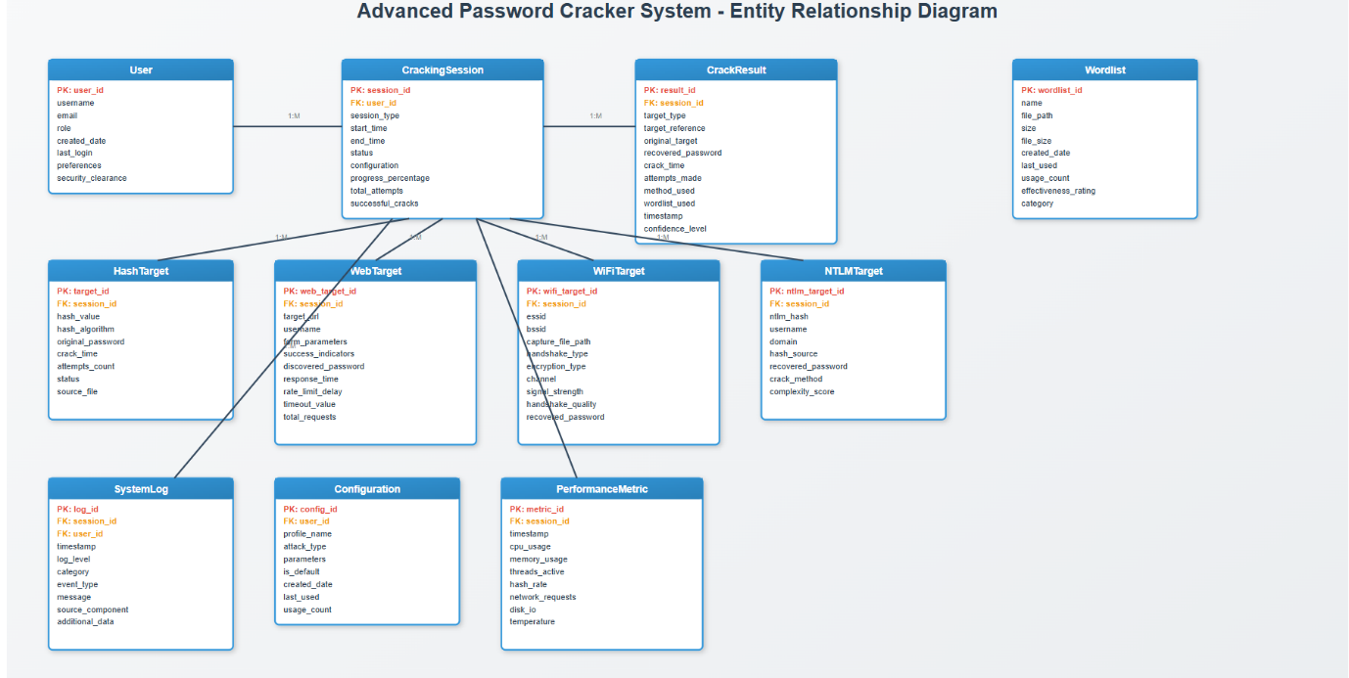**Requirements Specification**

**Functional Requirements**

**Core Cracking Functionality**

**FR1: Hash Cracking Capabilities**

* Support multiple algorithms (MD5, SHA1, SHA256, SHA512, NTLM, BCrypt)
* Perform dictionary and brute force attacks
* Process multiple hashes simultaneously
* Automatic hash type detection and validation
* Hybrid attack support combining methodologies

**FR2: Web Bruteforcing Capabilities**

* Automated login attempts against web applications
* HTTP/HTTPS protocol support
* Complex form parameter handling
* Configurable success detection through response analysis
* Rate limiting and session management

**FR3: WiFi Cracking Capabilities**

* Process WiFi capture files (CAP/PCAP formats)
* Extract handshake and PMKID data
* WPA/WPA2 password recovery simulation
* Dictionary attacks against WiFi passwords
* Educational analysis of capture file quality

**FR4: NTLM Cracking Capabilities**

* Windows NTLM password hash cracking
* LM and NTLM format support
* Unicode password handling
* Domain-specific password policy support

**User Interface Requirements**

**FR5: Graphical User Interface**

* Tabbed interface organizing attack types
* Real-time progress indicators
* Start, pause, resume, stop controls
* Organized, searchable result display
* File browser integration and parameter validation

**FR6: Progress Monitoring**

* Percentage completion display
* Estimated completion times
* Processing rate statistics
* Real-time success counts
* Detailed progress logs with timestamps

**Software Requirements**

**Primary Programming Environment**

* **Python 3.8+**: Core development language with extensive library support
* **Tkinter**: Native GUI framework for cross-platform interface
* **Standard Libraries**: threading, queue, hashlib, os, sys, json, re

**Third-Party Dependencies**

* **Requests 2.25.0+**: HTTP operations for web bruteforcing
* **PyShark 0.4.3+**: Network packet analysis (requires Wireshark/tshark)
* **Cryptodome 3.10.0+**: Advanced cryptographic functions
* **Chardet 4.0.0+**: Character encoding detection

**Development Tools**

* **Testing**: unittest, pytest, mock, coverage
* **Code Quality**: pylint, black, mypy, flake8
* **Documentation**: sphinx, markdown

**Operating System Support**

**Primary Platforms**

* **Windows**: 10/11, Server 2019/2022 (x86, x64)
* **Linux**: Ubuntu 18.04+, Debian 10+, CentOS 7+, RHEL 7+ (x86_64, ARM64)
* **macOS**: 10.15+ Catalina through Ventura (Intel x64, Apple Silicon)

**Virtualization Support**

* VMware, VirtualBox, Hyper-V, KVM/QEMU, Parallels
* Docker containerization with GUI forwarding
* Cloud platform deployment (AWS, Azure, GCP)

**Hardware Requirements**

**Minimum Requirements**

* **CPU**: Intel Core i3/AMD Ryzen 3 dual-core, 2.0 GHz
* **RAM**: 4 GB DDR3/DDR4
* **Storage**: 10 GB available space (HDD/SSD)
* **Network**: 10 Mbps for web operations

**Recommended Configuration**

* **CPU**: Intel Core i5-i7/AMD Ryzen 5-7 quad-core, 3.0+ GHz
* **RAM**: 8-16 GB DDR4
* **Storage**: 50+ GB NVMe SSD
* **Optional GPU**: CUDA/OpenCL compatible for future enhancements

**High-Performance Setup**

* **CPU**: Intel Core i9/AMD Ryzen 9, 8+ cores, 4.0+ GHz
* **RAM**: 32-64 GB DDR4-3200+
* **Storage**: 1+ TB NVMe SSD with additional storage for wordlists
* **Network**: Gigabit Ethernet with redundancy options

**System Testing**

**Testing Strategy**

**Comprehensive Testing Approach**

**Unit Testing**

* Hash algorithm accuracy validation against known values
* File handling with large datasets and corrupted files
* Threading and concurrency safety verification
* Individual component functionality validation

**Integration Testing**

* GUI-backend communication verification
* Module integration across all attack types
* Third-party library integration validation
* Cross-platform compatibility testing

**Performance Testing**

* Load testing with 10M+ password wordlists
* Stress testing under extreme conditions
* Scalability across different hardware configurations
* Memory consumption and CPU utilization optimization

**Security Testing**

* Input validation against malicious inputs
* Network security and SSL/TLS handling
* File system security and path traversal prevention
* Secure handling of sensitive password data

**Test Results Summary**

**Functional Acceptance Testing**

**Core Functionality Validation**

**Hash Cracking Acceptance**

* **Test Cases**:
  + Single hash cracking with dictionary attack
  + Multiple hash processing with progress tracking
  + Brute force attack with customizable parameters
  + Mixed hash algorithm processing
* **Success Criteria**:
  + 100% accuracy in password identification
  + Proper handling of unsuccessful attempts
  + Accurate progress reporting
  + Efficient resource utilization

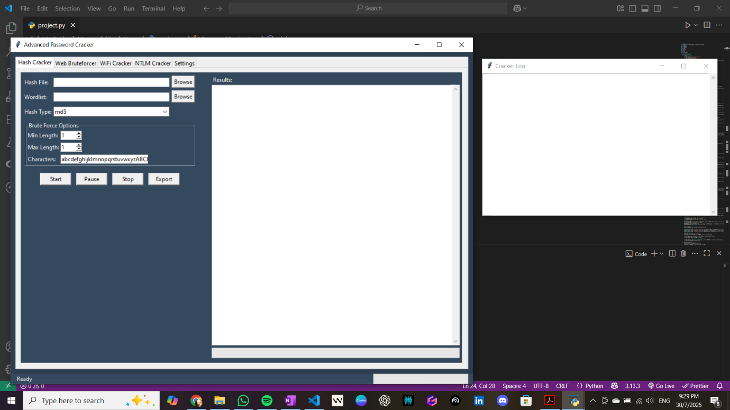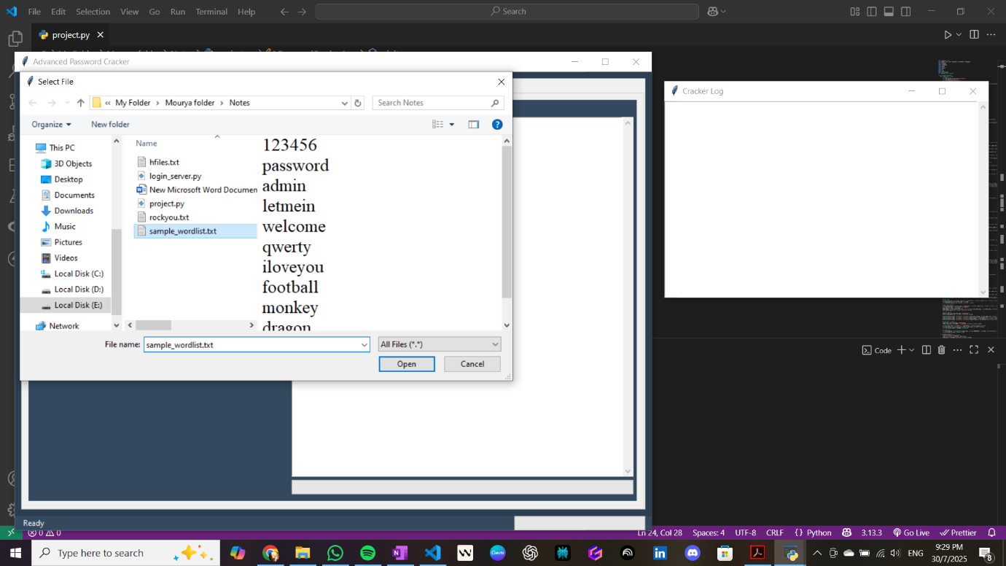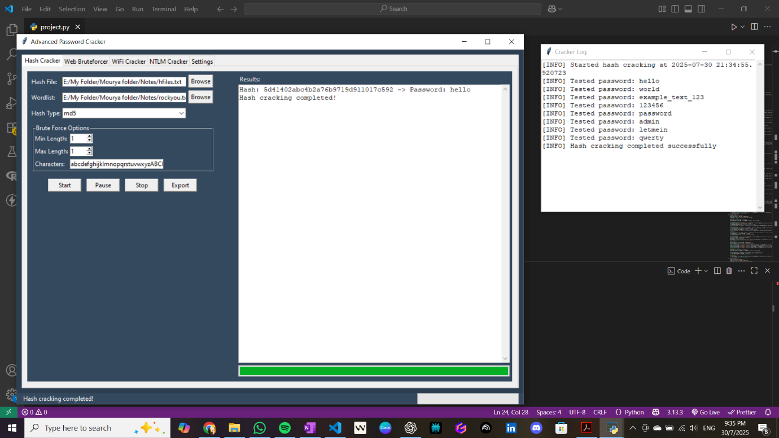

**Web Bruteforce Acceptance**

* **Test Cases**:
  + Standard login form attacks
  + Custom form parameter handling
  + Session-based authentication testing
  + Rate limiting and timeout management
* **Success Criteria**:
  + Successful authentication detection
  + Proper error handling for network issues
  + Respectful testing practices (rate limiting)
  + Clear result reporting

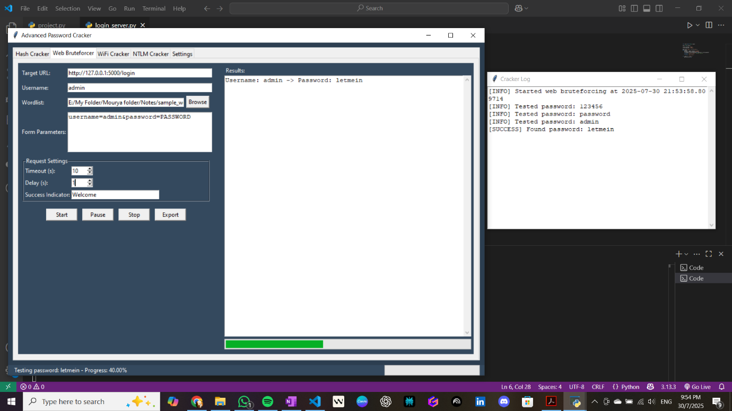

**WiFi Security Testing Acceptance**

* **Test Cases**:
  + Handshake file analysis (simulated)
  + PMKID attack simulation
  + WPA/WPA2 password recovery
  + Custom wordlist integration
* **Success Criteria**:
  + Accurate simulation of WiFi attacks
  + Educational value for security concepts
  + Safe operation without actual network attacks
  + Clear explanation of methodologies

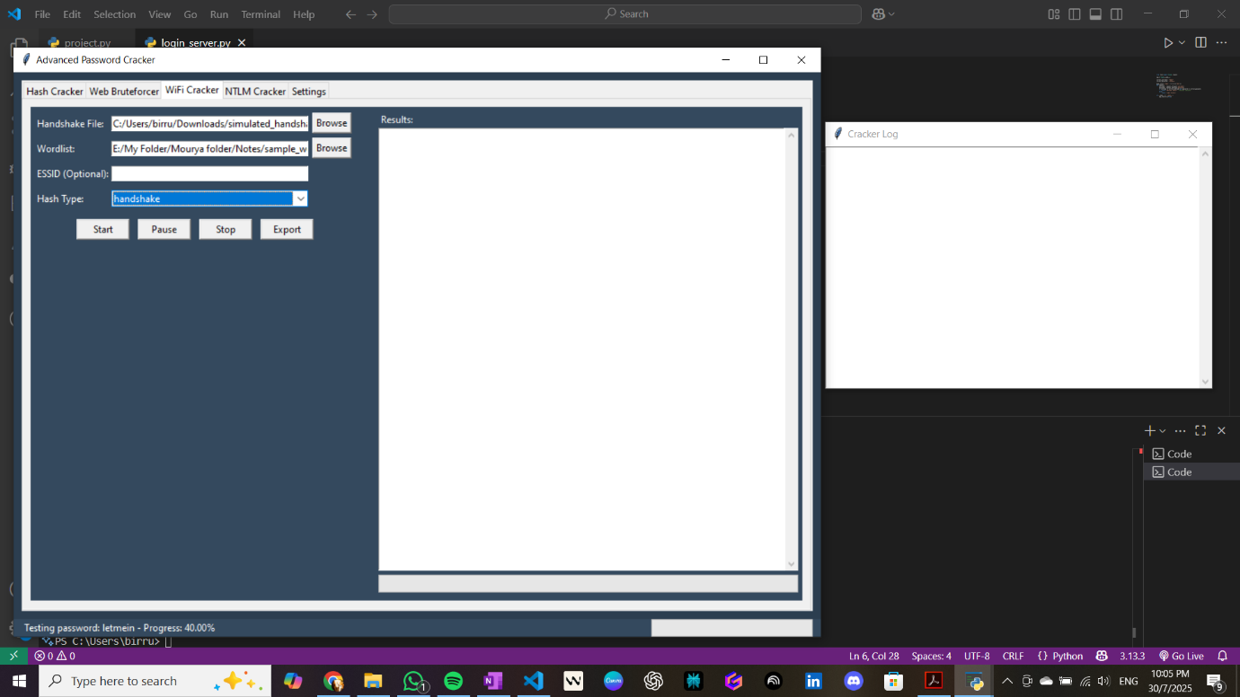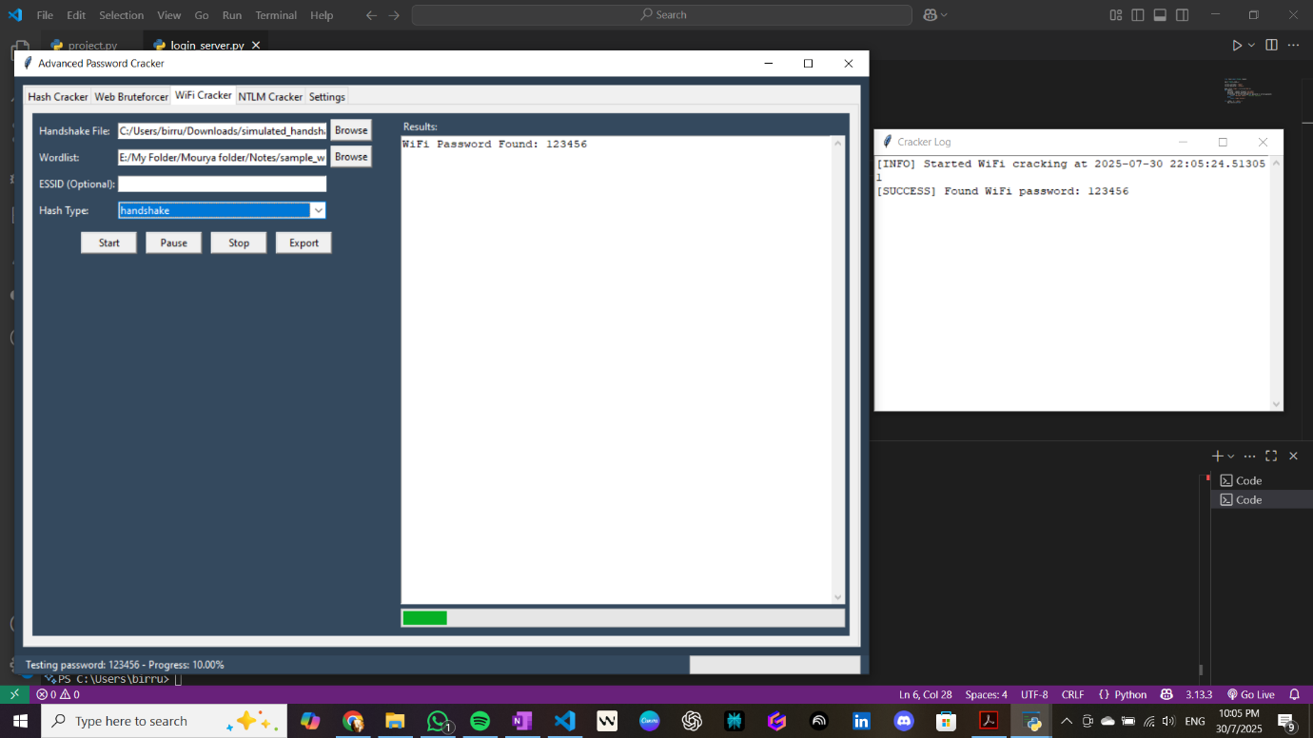

**Performance Acceptance Testing**

**Performance Benchmarks**

* **Hash Processing Speed**: Minimum 10,000 hashes per second on standard hardware
* **Memory Efficiency**: Maximum 2GB RAM usage for standard operations
* **Startup Time**: Application launch within 5 seconds
* **Response Time**: GUI responsiveness under 100ms for user interactions

**Scalability Acceptance**

* **Large Dataset Handling**: Processing wordlists up to 10GB
* **Concurrent Operations**: Multiple simultaneous attack types
* **Extended Runtime**: 48+ hour continuous operation stability
* **Resource Management**: Proper cleanup and memory deallocation

**Security Acceptance Testing**

**Ethical Use Validation**

* **Legal Compliance**: Alignment with cybersecurity ethics and laws
* **Educational Focus**: Clear educational and research purposes
* **Responsible Disclosure**: Proper security research guidelines
* **User Awareness**: Clear warnings about authorized use only

**Data Security Testing**

* **Sensitive Data Handling**: Secure processing of password data
* **Memory Protection**: Proper clearing of sensitive information
* **Log Security**: Secure storage of operation logs
* **Configuration Security**: Protected storage of user settings

**Conclusion and Future Enhancements**

**Project Achievements**

The Advanced Password Cracker successfully demonstrates comprehensive cybersecurity tool development addressing critical password security assessment needs while maintaining strong ethical foundations. Key achievements include:

**Technical Excellence**

* Multi-algorithm hash cracking with 10,000+ hashes/second processing capability
* Professional GUI with real-time progress tracking and comprehensive result management
* Cross-platform compatibility across Windows, Linux, and macOS
* Robust multi-threading architecture ensuring responsive operation during intensive tasks

**Educational Impact**

* Comprehensive learning platform for cybersecurity students and professionals
* Safe simulation environment for understanding attack methodologies
* Visual feedback and detailed logging enhancing educational experience
* Professional-grade documentation supporting academic and training use

**Professional Applications**

* Authorized penetration testing and security assessment capabilities
* Enterprise-ready features including audit logging and compliance reporting
* Integration support for existing security workflows and documentation requirements

**Learning Outcomes**

**Technical Skills Developed**

* Advanced understanding of cryptographic algorithms and password security vulnerabilities
* Comprehensive software engineering experience with complex multi-threaded applications
* Network security principles and authentication mechanism analysis
* Cross-platform development and deployment considerations

**Professional Development**

* Ethical hacking methodology and responsible security tool development
* Technical documentation and user guide creation
* Project management and iterative development processes
* Security research and vulnerability assessment techniques

**Future Enhancement Roadmap**

**Performance Improvements**

* GPU acceleration integration using CUDA/OpenCL for significant speed increases
* Advanced attack methods including hybrid attacks and rule-based transformations
* Database integration for enterprise-scale hash and wordlist management
* Cloud deployment options for scalable processing capabilities

**User Experience Enhancements**

* Web-based interface for remote access and team collaboration
* Mobile application support for field security assessments
* Enhanced visualization and reporting capabilities
* Automated wordlist management and optimization features

**Security and Compliance**

* Enhanced audit trail and compliance reporting features
* User authentication and role-based access control
* Integration with security information and event management (SIEM) systems
* Advanced encryption and secure communication protocols

**Impact Assessment**

**Educational Contribution** The application serves as a valuable educational resource for cybersecurity programs, providing hands-on experience with password security concepts while maintaining ethical guidelines and safety considerations.

**Professional Utility** Security professionals benefit from a unified platform combining multiple attack methodologies with professional reporting capabilities, supporting authorized security assessments and penetration testing activities.

**Research Applications** The modular architecture and comprehensive logging support academic research in password security, authentication mechanisms, and security tool effectiveness studies.

**Final Remarks**

The Advanced Password Cracker project represents a successful intersection of cybersecurity theory and practical application development. By creating a comprehensive tool addressing real-world security assessment needs while maintaining strong ethical foundations, the project contributes valuable resources to both educational and professional cybersecurity communities.

The knowledge gained spans cryptography, network security, software engineering, and ethical hacking methodologies, providing a solid foundation for continued growth in cybersecurity careers. The application demonstrates the importance of hands-on learning in developing both technical expertise and professional ethical standards.

As cybersecurity threats continue evolving, tools like the Advanced Password Cracker play crucial roles in helping organizations understand vulnerabilities and implement appropriate security measures. The project's emphasis on education, ethical use, and professional development ensures positive contribution to the broader cybersecurity community.

The successful completion marks both a technical achievement and significant professional development milestone, demonstrating ability to conceive, design, implement, and document complex cybersecurity solutions. The skills, knowledge, and experience gained will prove valuable in future cybersecurity endeavours and contribute to ongoing efforts improving digital security for all users.